MOSHI CO-OPERATIVE UNIVERSITY

DESIGNING AND DEVELOPMENT OF SMART LIBRARY NOISE DETECTION AND MONITORING SYSTEM: CASE STUDY OF MOSHI CO-OPERATIVE UNIVERSITY.

PROJECT REPORT

BY

GROUP 05: WIRELESS TECHNOLOGY AND AUTOMATION

Bachelor of Business Information and Communication Technology.

SUPERVISOR: Mr. SAMWEL KATWALE

A Project Report Submitted to the Department of Information and Communication Technology in Partial Fulfilment of the Requirements for the Award of the Degree of Business Information and Communication Technology of the Moshi Co-operative University

February, 2026

DECLARATION
We declare that this project report is our own original work and that it has not been presented and will not be presented to any other higher learning Institution for a similar or any other academic award.
Student name | Registration number | Signature
Mathew Fredy | MoCU/BBICT/1058/23 | ..........................
Isack Kasian Kiwia | MoCU/BBICT/1109/23 | ..........................
Spencioza Valentine Nyangoma | MoCU/BBICT/1114/23 | ..........................
Dainess Moses Jacob | MoCU/BBICT/1104/23 | ..........................
Godwine Leo Jasson | MoCU/BBICT/1124/23 | ..........................
Abdul Juma Yusuf | MoCU/BBICT/1116/23 | ..........................
Vancee Anthony Mbango | MoCU/BBICT/1068/23 | ..........................
Ellen John Kuyenga | MoCU/BBICT/1123/23 | ..........................
Rashid Hassan Juma | MoCU/BBICT/1111/23 | ..........................

CERTIFICATION
The undersigned certify to have read and hereby recommend for acceptance by the Moshi Co-operative University a Project Report titled “DESIGNING AND DEVELOPMENT OF SMART LIBRARY NOISE DETECTION AND MONITORING SYSTEM: CASE STUDY OF MOSHI CO-OPERATIVE UNIVERSITY” in partial fulfillment of the requirements for the award of a degree of Bachelor of Business Information and Communication Technology of Moshi Co-operative University.
…………………………………………..
(Supervisor’s Name)
……………………………………………
(Supervisor’s Signature)
………………………………………………
(Date)

ACKNOWLEDGEMENT
In the tapestry of our academic journey, there are threads of gratitude that weave the story of this project's completion. At this juncture, we pause to express our heartfelt appreciation to those who have contributed to this meaningful endeavor.
First and foremost, we offer our deepest gratitude to Almighty God, the unseen hand that guided our efforts. His grace illuminated our path and strengthened our resolve throughout this project.
We extend our sincere appreciation to our parents, whose unwavering support and encouragement have been the foundation of our aspirations. Their belief in us has been a driving force behind our pursuit of knowledge and personal growth.
Our profound gratitude goes to our supervisor, Mr. Samwel Katwale, for his invaluable guidance and patience. His mentorship, constructive feedback, and continuous encouragement served as a compass, directing us through this intellectual exploration.
We are grateful to Moshi Co-operative University (MoCU) for providing an environment conducive to learning and growth. The opportunities and resources offered by the institution have been instrumental in shaping our academic journey.
To the participants who shared their perspectives and insights, we extend our appreciation. Their engagement added depth and richness to our project, enhancing the quality of our work.
Finally, we acknowledge the collective efforts of all who have contributed, whether directly or indirectly, to the successful completion of this project. Their support and contributions have left an indelible mark on our academic experience.
May this tapestry of gratitude stand as a testament to our shared commitment to knowledge, growth, and the pursuit of excellence.

LIST OF ABBREVIATIONS
ADC: Analog-to-Digital Converter
AP: Access Point
dB: Decibel
ESP32: A series of low-cost, low-power system on a chip microcontrollers with integrated Wi-Fi and dual-mode Bluetooth
FR: Functional Requirement
HTML: HyperText Markup Language
HTTP: Hypertext Transfer Protocol
I2C: Inter-Integrated Circuit
IoT: Internet of Things
LCD: Liquid Crystal Display
LED: Light Emitting Diode
MAX4466: A type of electret microphone amplifier module used for sound detection
MoCU: Moshi Co-operative University
NFR: Non-Functional Requirement
UART; Universal Asynchronous Receiver-Transmitter
Wi-Fi: Wireless Fidelity

LIST OF TABLES
Table 1: functional requirements 19
Table 2: non-functional requirements 20
Table 3: actors and actions 21
Table 4: Smart Library Noise Monitoring System hardware components 23
Table 5: Smart Library Noise Monitoring System front-end implementation 23
Table 6: Smart Library Noise Monitoring System back-end implementation 23
Table 7: Smart Library Noise Monitoring System libraries and frameworks used 23
Table 8: work plan (project timeline) and activity 30
Table 9: group member and distributed roles 30

LIST OF FIGURES
Figure 1: Project Framework 14
Figure 2: Smart Library Noise Monitoring System Use Case Diagram 21
Figure 3: Smart Library Noise Monitoring System flowchart 22
Figure 4: System Development Model for Smart Library Noise Monitoring System 24
Figure 5: Library administrator and library Staff Interface 25

Table of Contents
DECLARATION i
CERTIFICATION ii
CHAPTER ONE 1
1.0 INTRODUCTION 1
1.1 Background of the Study 1
1.2 Statement of the Problem 2
1.3 Objectives of the Study 2
1.3.1 General Objective 2
1.3.2 Specific Objectives 2
1.4 Research Questions 2
1.5 Significance of the Study 3
1.6 Scope of the Study 3
2.0 LITERATURE REVIEW 4
2.1 Library Noise Control and Accessibility 4
2.2 Understanding Noise Detection and Monitoring Systems 4
2.3 Theoretical Literature 5
2.4 Empirical Literature 5
2.5 Noise Detection and Monitoring Systems 5
2.5.1 IoT-Based Noise Monitoring 5
2.5.2 Embedded Sensor-Based Noise Systems 6
2.6 Library Noise Management Practices in Academic Institutions 6
2.7 Project Framework 6
2.8 Research Gap 7
3.0 RESEARCH METHODOLOGY 8
3.1 Study Area 8
3.2 Research Design and Approach 8
3.2.1 Research Design 8
3.2.2 Research Approach 9
3.3 Target Population 9
3.3.1 Library Users 9
3.3.2 Library Staff 9
3.3.3 Library Administrators 9
3.4 Sampling 10
3.4.1 Sampling Frame 10
3.4.2 Sample Size Determination 10
3.4.3 Sampling Techniques 10
3.5 Data Collection 10
3.5.1 Data Collection Instruments 10
3.6 Data Analysis 10
3.7 Ethical Considerations 11
4.0 RESULTS AND DISCUSSION 12
4.1 Introduction 12
4.1 Results 12
4.1.1 Requirements for the Smart Library Noise Detection and Monitoring System 12
4.1.2 System Modeling 13
4.1.3 System Implementation 16
iv. Libraries and Frameworks Used 16
4.1.4 System Development Model 17
4.1.5 System Features 17
4.1.6 System Verification and Validation 18
4.2 Discussion 19
5.0 SUMMARY, CONCLUSION, AND RECOMMENDATIONS 20
5.1 Summary 20
5.2 Conclusion 20
5.3 Recommendations 21
References 22

CHAPTER ONE

1.0 INTRODUCTION

1.1 Background of the Study
Libraries are central to higher learning institutions, serving as hubs for knowledge acquisition, research, and academic collaboration. The effectiveness of a library in supporting learning and research activities depends not only on the availability of resources but also on the maintenance of an environment conducive to study. Noise and disturbances in library spaces have been consistently identified as barriers to concentration, productivity, and overall academic performance (Irawan et al., 2022).
Traditionally, libraries rely on manual supervision or simple signage to manage noise levels. Library staff are expected to patrol study areas and remind users to maintain silence, while students are expected to self-regulate their behavior. However, these approaches often prove insufficient due to human limitations, inconsistent enforcement, and delayed feedback, resulting in persistent disturbances that affect users’ learning experiences.
Several studies have explored technological approaches to monitoring environmental conditions in public and academic spaces. Noise detection systems using sound sensors and IoT devices have shown promise in automating environmental monitoring, providing real-time feedback, and enabling remote management (Bartalucci et al., 2024). Similarly, systems integrating automated alerts and dashboards have been successfully applied in smart classrooms, hospitals, and office environments to maintain compliance with noise thresholds and improve operational efficiency.
Despite these advances, most existing systems are either general-purpose noise monitors or isolated alert systems that do not integrate automated notifications, user feedback, and data logging in real-time for academic library contexts. This fragmentation limits their effectiveness in proactively maintaining a quiet study environment and providing actionable insights to library management.
This study aims to design and develop a smart library noise detection and monitoring system that continuously monitors noise levels, provides immediate feedback to library users through voice alerts, tracks repeated violations, and notifies library staff via a Wi-Fi-enabled dashboard when excessive noise persists. The system seeks to create a conducive study environment, reduce manual supervision, and provide data-driven insights for efficient library management.

1.2 Statement of the Problem
Libraries are intended to be silent study spaces; however, maintaining silence has become increasingly difficult. Many students generate noise beyond acceptable levels, either intentionally or unintentionally. Librarians are forced to continuously patrol the library to warn noise makers, which disrupts both staff workflow and library users who are already observing the rules (Maulidda et al., 2024a).
Repeated physical warnings often lead to interruptions and tension between librarians and students. In addition, some library users ignore printed notices or are unaware of noise regulations(Hidayat et al., 2019). As a result, excessive noise causes loss of concentration, reduced productivity, miscommunication, and discomfort among serious learners.
The absence of an automated noise monitoring and control system means that noise management depends entirely on human effort, which is inefficient and inconsistent (Ni’am & Irawan, 2024). Therefore, there is a need for a smart, automated system capable of detecting noise levels and responding appropriately in real time without relying solely on human supervision.

1.3 Objectives of the Study

1.3.1 General Objective
To design and develop a Smart Library Noise Detection and Monitoring System that automatically detects excessive noise levels and enforces silence using wireless technology.

1.3.2 Specific Objectives
- To analyse requirements for noise monitoring and user needs.
- To design the system architecture and data flow.
- To implement hardware and software for detection and alerts.
- To test and verify system accuracy and reliability.
- To deploy the system with remote notifications for librarians.

1.4 Research Questions
The study seeks to answer the following questions:
- How can environmental noise in a library be effectively detected using sound sensors?
- How can automated voice alerts be implemented to control excessive noise?
- How can wireless technology be used to notify librarians in real time?
- How effective is an automated noise monitoring system in reducing library disturbances?

1.5 Significance of the Study
The findings and outcomes of this project are expected to benefit various stakeholders:
Help providing a quieter study environment that improves concentration and academic performance.
It Help librarian by reducing the need for constant physical supervision and manual warnings.
It improves library management efficiency through the adoption of smart technologies.

1.6 Scope of the Study
The project focuses on the design and implementation of a noise monitoring system for indoor library environments. The system monitors sound levels within a predefined decibel range and issues automated voice warnings when thresholds are exceeded. The project does not include video surveillance or user identification; it is limited to audio-based detection and wireless notification.

CHAPTER TWO

2.0 LITERATURE REVIEW

2.1 Library Noise Control and Accessibility
Library noise control refers to the ability of academic institutions to maintain an environment conducive to learning, research, and study. Excessive noise negatively affects concentration, comprehension, and academic performance. According to (Maulidda et al., 2024) Traditional methods of maintaining silence in libraries rely on manual supervision, such as librarians issuing verbal warnings or posting notice boards. These methods are often inefficient and inconsistent, particularly in large or busy libraries where monitoring all users continuously is not feasible (Irawan et al., 2022).
The adoption of smart noise monitoring systems modernizes library management by providing automated, real-time monitoring of sound levels. By using sensors and digital controllers, the system can detect noise intensity, compare it with predefined thresholds, and trigger immediate corrective actions. Such systems reduce reliance on manual supervision and ensure a consistent and controlled learning environment, improving both user experience and operational efficiency (World Health Organization, 2018).

2.2 Understanding Noise Detection and Monitoring Systems
Noise detection and monitoring systems are technological solutions designed to measure, analyse, and regulate sound levels in specific environments. Traditional methods, such as standalone sound meters, provide only a snapshot of noise and lack automated response mechanisms, requiring manual observation and intervention (Maulidda et al., 2024). Consequently, these methods are ineffective in maintaining consistent silence in dynamic library environments.
Modern systems incorporate embedded sound sensors, microcontrollers, and feedback mechanisms to automate the monitoring process. Noise levels are continuously recorded and processed, and alerts are triggered when sound exceeds acceptable limits (Bartalucci et al., 2024). This approach ensures real-time intervention, enabling library users to adjust their behaviour immediately. Additionally, these systems allow data logging for analysis of peak noise periods, helping administrators improve spatial organization and operational planning (International Organization for Standardization, 2019).

2.3 Theoretical Literature
This project is grounded in the principles of cybernetics and automation, specifically feedback control systems. In a feedback control system, the output is continuously monitored and compared against a set point, with feedback generated to correct any deviation. In this study, the system operates as a closed-loop control system, where library noise is the output, the threshold is the reference value, and warnings or alerts are the feedback mechanism (Bartalucci et al., 2024).
The theory of feedback control provides a basis for automating the regulation of human behaviour within a controlled environment. By continuously monitoring noise and providing immediate corrective feedback, the system ensures that acceptable sound levels are maintained, reflecting the principles of modern automation and control engineering.

2.4 Empirical Literature
Several studies have examined the application of technology for noise monitoring in indoor environments. Traditional libraries mostly rely on manual supervision and sound meters, but these methods lack automated response capabilities. Research in smart classrooms and smart offices demonstrates that IoT sensors are effective for continuous environmental monitoring, including noise detection (Maulidda et al., 2024a).
For example, systems using decibel meters combined with visual alerts have been trialed, but often require human attention to interpret the feedback. The proposed smart library system improves upon this by integrating direct audio warnings and real-time alerts to librarians and users. This approach ensures immediate corrective action, making noise management more efficient and responsive than previous solutions.

2.5 Noise Detection and Monitoring Systems

2.5.1 IoT-Based Noise Monitoring
IoT-based systems employ sound sensors connected to microcontrollers, transmitting data to a central server or cloud platform. These systems allow real-time monitoring, remote access, and data visualization, making them suitable for large-scale environments (Eridani et al., 2022). While highly effective, IoT systems may require internet connectivity and can involve higher deployment costs.

2.5.2 Embedded Sensor-Based Noise Systems
Embedded sensor systems use sound sensors (MAX4466), microcontrollers (ESP32), and alert mechanisms to detect and respond to noise locally. These systems are cost-effective, reliable, and suitable for indoor environments like libraries, where immediate feedback is critical (Irawan et al., 2022). The system can automatically trigger LED indicators, voice warnings, or notifications to staff, ensuring timely corrective action.

2.6 Library Noise Management Practices in Academic Institutions
In many academic institutions, including public libraries, noise control is still manual and reactive. Users are expected to adhere to silence rules, and violations are addressed verbally by staff (Eridani et al., 2022). This approach is inefficient, especially during peak hours or in large libraries where supervision is limited.
The lack of automated monitoring tools makes it difficult to detect persistent disturbances or noise hotspots. Consequently, noise issues may remain unaddressed, affecting user satisfaction and learning effectiveness. These challenges highlight the need for an automated, smart noise monitoring system to support librarians and maintain a quiet academic environment.

2.7 Project Framework
The project framework illustrates the interaction between the main components and users of the smart library noise detection and monitoring system.
Sound Sensor detects noise levels within the library environment.
Controller processes sound data and compares it with predefined thresholds.
Display/Alert Unit provides visual or audible warnings when noise exceeds acceptable levels.
Library Staff monitor alerts and take necessary action when required.
Library Users receive feedback and adjust their behavior accordingly.
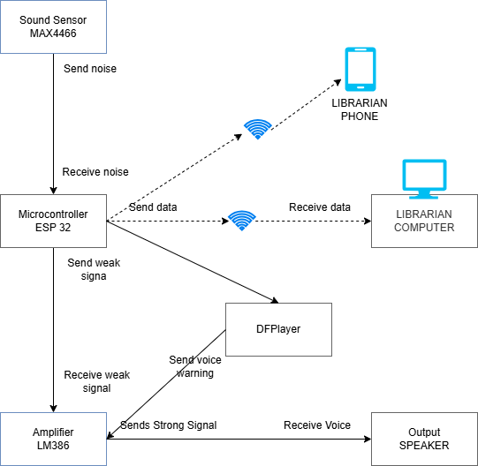
Figure 1: Project Framework

2.8 Research Gap
Although several noise monitoring systems have been developed for classrooms and public environments, there is limited implementation of smart noise detection systems specifically tailored for library settings in many academic institutions. Existing solutions often focus on urban noise pollution or industrial environments rather than indoor academic spaces that require strict silence control.
Furthermore, many libraries continue to rely on manual noise control methods, which are inefficient and inconsistent. This project aims to address these gaps by designing a smart, cost-effective, and locally deployable library noise detection and monitoring system that enhances learning conditions and supports library management.

CHAPTER THREE

3.0 RESEARCH METHODOLOGY

3.1 Study Area
The study area for this research is Moshi Co-operative University, located in Moshi Municipal within the Kilimanjaro region. The university library was selected as the site for system implementation and testing, providing a real-world environment to evaluate the effectiveness of the Smart Library Noise Detection and Monitoring System.
The library setting offers a diverse range of activities, including individual study, group discussions, and computer use, which present typical noise challenges. By focusing on noise control within this academic environment, the project targets a critical factor affecting students’ concentration, learning outcomes, and overall library experience. The controlled environment allows for systematic monitoring, data collection, and validation of the system’s functionality before potential wider deployment.

3.2 Research Design and Approach
The project employed a design and development research approach, which is ideal for addressing practical problems through technology-based solutions. This approach involved designing a prototype system, integrating hardware and software components, and testing its performance under simulated and actual library conditions (Bartalucci et al., 2024).
The research design is primarily quantitative, aiming to collect measurable data on library noise levels, system response times, and user feedback on alert effectiveness. Quantitative data were supplemented with observations to ensure a holistic understanding of system performance and usability.

3.2.1 Research Design
The research design focuses on structured development and evaluation of the smart noise monitoring system. Noise levels were measured and analysed using the MAX4466 sound sensor, processed via the ESP32 microcontroller, and compared against predefined thresholds. Observations of user behaviour and system alerts were recorded to evaluate effectiveness (Bartalucci et al., 2024).
This structured approach ensured that all components were systematically tested and optimized to deliver accurate, reliable, and actionable feedback for maintaining acceptable library noise levels.

3.2.2 Research Approach
The system development followed a phased approach:
- Prototype Design: Initial circuit layout on a breadboard with the MAX4466 sensor, ESP32, LM386 amplifier, and speaker.
- Programming: Development of logic for noise detection, threshold comparison, timers, counters, and automated voice warnings using Arduino IDE.
- Integration: Combining hardware and software components to create a fully operational system.
- Testing: Evaluation in the library environment to assess detection accuracy, response time, and user interaction.
This approach ensured data-driven refinement of the system, aligning technical performance with user requirements for noise control.

3.3 Target Population
The target population for this study comprises library users, library staff, and administrative personnel, each playing a key role in the effectiveness and adoption of the noise monitoring system:

3.3.1 Library Users
Students and other library visitors are the primary beneficiaries of the system. They interact with the system indirectly, adjusting their behavior in response to alerts and warnings. Their experience and feedback are crucial to evaluate usability and effectiveness.

3.3.2 Library Staff
Staff members monitor the system’s alerts and ensure corrective actions when necessary. They provide feedback on the accuracy of alerts, reliability of notifications, and overall contribution to maintaining a quiet environment.

3.3.3 Library Administrators
Administrators oversee system performance, review logged data, and analyze trends to improve library management. Their role includes monitoring peak noise periods and assessing the system’s contribution to library operations.

3.4 Sampling

3.4.1 Sampling Frame
The sampling frame includes all active library users and staff within the selected section of the university library. This frame ensures that data collection reflects typical activity patterns and noise behaviours in the target environment.

3.4.2 Sample Size Determination
Given the manageable size of the library population, a census approach was adopted for quantitative data collection. All library users and staff present during the study period were included to ensure full representation of noise patterns, system interactions, and feedback.

3.4.3 Sampling Techniques
A purposive sampling technique was used to focus on participants who actively use the library or interact with staff during operational hours. This ensured the collection of relevant and meaningful data, capturing typical noise events and responses to system alerts.

3.5 Data Collection

3.5.1 Data Collection Instruments
Data were collected using:
Sound Sensors (MAX4466) – to measure real-time noise levels.
Observation Checklists – to record user and staff responses to alerts.
Questionnaires – to capture feedback on alert effectiveness, usability, and system reliability.
Structured and semi-structured questionnaires were distributed to library staff and users, while sensor data provided objective quantitative measurements of noise levels.

3.6 Data Analysis
Quantitative data from the sensors were analyzed using descriptive statistics, including mean noise levels, standard deviation, frequency of alerts, and response times. Observational and feedback data were analyzed to identify trends in behavioural adjustments, system usability, and operational effectiveness.
The analysis provided insights into how effectively the system detects and responds to excessive noise, user compliance with alerts, areas for optimization in alert thresholds or delivery methods

3.7 Ethical Considerations
The research was conducted with strict adherence to ethical standards:
- Informed Consent, all participants were fully informed about the study objectives and provided consent prior to participation.
- Privacy and Confidentiality, personal data were anonymized and stored securely.
- Minimizing Harm, the study posed minimal risk to participants, with alerts designed to encourage compliance without causing discomfort.
- Professional Conduct researchers maintained respectful interactions with participants throughout the study.

CHAPTER FOUR

4.0 RESULTS AND DISCUSSION

4.1 Introduction
This chapter presents the results of the design, development, and testing of the Smart Library Noise Detection and Monitoring System. Following the assembly of hardware components and completion of programming, the system was modeled, implemented, and rigorously evaluated. This chapter details the final system requirements, system modeling process, implementation outcomes, and the results of verification and validation tests. Finally, it provides a discussion of the findings and their implications for improving the library study environment.

4.1 Results

4.1.1 Requirements for the Smart Library Noise Detection and Monitoring System
In this project, requirements define the features and functionalities that the system must fulfill to effectively monitor noise levels and assist library staff in maintaining a quiet study environment. Requirements are divided into functional and non-functional categories.

Functional Requirements
Table 1: functional requirements
Requirement ID | Requirement | Description
FR1 | Noise Detection | Continuously monitor library noise levels using MAX4466 sound sensor.
FR2 | Threshold Alert | Trigger warnings when noise exceeds 40–50 dB.
FR3 | Voice Warnings | Provide immediate voice alerts to users when thresholds are exceeded.
FR4 | Warning Count | Track the number of warnings issued within a monitoring window.
FR5 | Remote Notification | Notify library staff via dashboard when repeated warnings occur.
FR6 | Monitoring Window | Operate within a 30-minute monitoring cycle, resetting counters afterward.
FR7 | Data Logging | Record noise events with timestamps for analysis and reporting.

Non-Functional Requirements
Table 2: non-functional requirements
Requirement ID | Requirement | Description
NFR1 | Performance | Detect and respond to noise events immediately, within 1 second of threshold breach.
NFR2 | Reliability | Operate continuously with minimal downtime.
NFR3 | Accuracy | Maintain ±2 dB precision in noise measurements.
NFR4 | Usability | Alerts should be clear and understandable to users.
NFR5 | Remote Monitoring | Dashboard notifications must be accessible to staff via Wi-Fi.
NFR6 | Scalability | Allow future expansion to multiple library zones.
NFR7 | Safety | Ensure all electrical components comply with public safety standards.

4.1.2 System Modeling
System modeling was conducted to conceptualize and illustrate interactions between system components and users, ensuring clarity in design and implementation.
System Elements:
Input: Noise levels detected by MAX4466 sensor.
Process: ESP32 microcontroller interprets sensor data, compares it with thresholds, counts warnings, and triggers alerts.
Output: Automated voice warnings through speakers and remote notifications to the librarian dashboard.
Use Case Diagram
Actors and interactions include
Table 3: actors and actions
Actors | Actions
Library Users | Receive voice alerts and adjust behavior.
Library Staff | Monitor alerts via dashboard and intervene when necessary
System | Detects noise, logs data, and issues warnings.
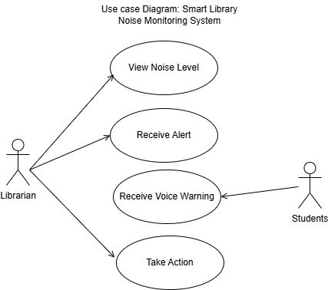
Figure 2: Smart Library Noise Monitoring System Use Case Diagram
Flow Chart
System Operational Rules and Threshold Configuration
The Smart Library Noise Monitoring System operates based on predefined noise thresholds, timing intervals, and enforcement logic to ensure effective and automated noise control within the library environment.
Noise Threshold Level 40–50 dB, the system is configured with a predefined noise threshold ranging between 40 and 50 decibels (dB), which represents the acceptable sound level for a standard library environment. Noise levels below this threshold are considered normal and do not trigger any system response. When the detected noise level exceeds this threshold, the system identifies the condition as excessive noise and initiates the warning mechanism.
Monitoring Window 30 Minutes, once excessive noise is detected for the first time, the system activates a 30-minute monitoring window. This time window is used to track repeated noise violations and manage warning escalation. All warnings issued within this duration are counted toward enforcement decisions. The monitoring window ensures that noise behavior is assessed over a defined period rather than reacting to isolated incidents.
Warning Interval 10 Minutes: The system enforces a 10-minute interval between successive voice warnings. After issuing the first warning, the system waits for ten minutes before issuing another warning, provided that excessive noise persists. This interval prevents frequent interruptions while still maintaining effective noise control and discipline.
Three-Warning Punishment Rule: If the system detects three (3) consecutive noise violations within the active 30-minute monitoring window, it automatically triggers a punishment alert. This alert is sent to the librarian via Wi-Fi, indicating persistent noise disturbance that requires administrative intervention. The punishment decision is not automated. instead, it supports human authority by notifying the librarian for appropriate action.
Automatic System Reset: At the expiration of the 30-minute monitoring window, the system automatically resets the warning counter and monitoring timer, regardless of whether a punishment alert was triggered. This reset mechanism ensures fairness by allowing a fresh monitoring cycle and prevents indefinite accumulation of warnings. After resetting, the system resumes continuous noise monitoring under normal conditions.
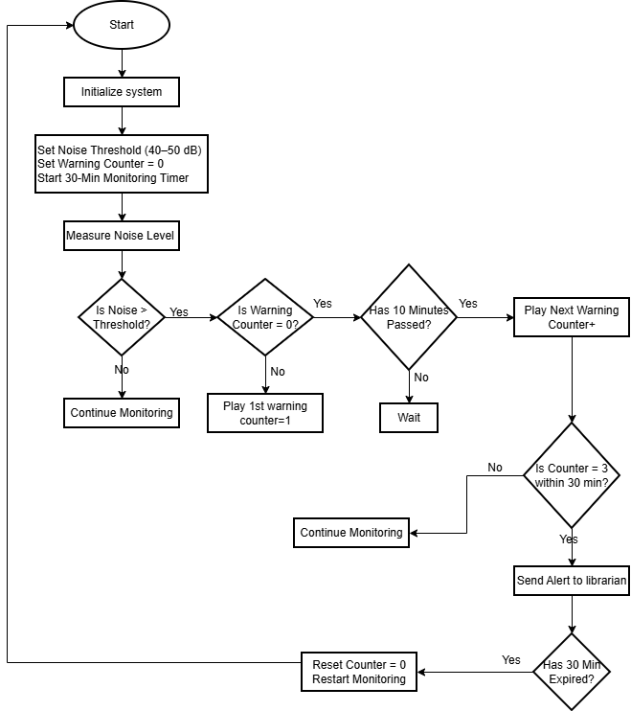
Figure 3: Smart Library Noise Monitoring System flowchart

4.1.3 System Implementation
- Hardware Components
Table 4: Smart Library Noise Monitoring System hardware components
Components | Functions
MAX4466 Sound Sensor | Detects ambient noise
ESP32 Microcontroller | Processes data and controls alert logic
LM386 Amplifier | Amplifies audio output
Speaker | Broadcasts voice warnings
Laptop | For programming, testing, and system configuration
DFPlayer and SD card | Storing audio for voice warning
- Front-End Implementation
Table 5: Smart Library Noise Monitoring System front-end implementation
Component | Function | Technologies Used
Voice Alerts | Broadcast warnings to library users | ESP32 Microcontroller, LM386 Amplifier, Speaker, Arduino IDE, DFPlayer, Recorded Audio Files
Dashboard, and Notifications | Display warning counts, timestamps, and active noise zones for staff | HTML, CSS
- Back-End Implementation
Table 6: Smart Library Noise Monitoring System back-end implementation
Component | Function | Technologies Used
Data Processing | Evaluate sensor input against thresholds | ESP32 Microcontroller, Arduino IDE, C++
Notifications | Send real-time alerts to staff via dashboard | Wi-Fi, HTTP requests

Libraries and Frameworks Used
Table 7: Smart Library Noise Monitoring System libraries and frameworks used
Library | Purpose
WiFi.h | ESP32 Wi-Fi client & access point (AP) management.
WebServer.h | Serves HTML pages for the dashboard over Wi-Fi.
Wire.h | I2C communication (used for LCD: LiquidCrystal_PCF8574).
LiquidCrystal_PCF8574.h | Controls the I2C-connected LCD screen.
HardwareSerial.h | ESP32 hardware serial communication (used for DFPlayer Mini UART).
DFRobotDFPlayerMini.h | Controls DFPlayer Mini MP3 module for voice alerts.
math.h | Provides logarithm (log10f) for ADC to dB conversion.

4.1.4 System Development Model
The system followed an Iterative and Incremental Development Model, which allowed phased testing and integration. Hardware setup and sensor calibration, implementation of voice warning logic and monitoring cycles, integration of Wi-Fi dashboard for staff notifications, and iterative testing for threshold detection, alert clarity, and remote notification reliability.
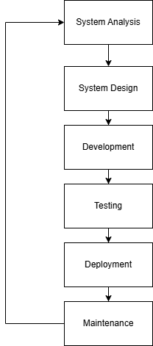
Figure 4: System Development Model for Smart Library Noise Monitoring System

4.1.5 System Features
- User-Side Features
Receive voice alerts for noise exceeding thresholds, visual indicators LEDs provide immediate feedback, and adjust behavior in response to alerts.
- Library administrator and library Staff-Side Features
Real-time dashboard monitoring, notifications after repeated warnings and access to logged noise data for analysis and decision-making.
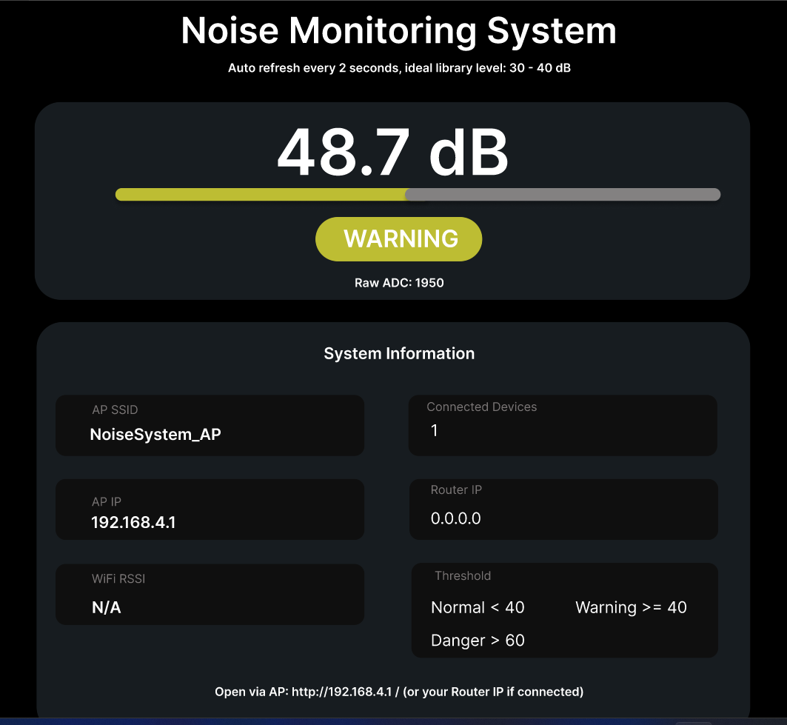
Figure 5: Library administrator and library Staff Interface

4.1.6 System Verification and Validation
- Verification and testing
Unit Testing: Individual modules, including sensor readings, voice alerts, and Wi-Fi notifications, were tested.
Integration Testing: Verified successful communication between sensor, ESP32, DFPlayer, speaker, and staff dashboard.
System Testing: Full system testing confirmed noise detection, voice warnings, data logging, and notifications worked as expected.
- Validation
Conducted with library staff and selected users, feedback confirmed alerts were clear, timely, and effective, and adjustments were made to optimize warning frequency and threshold sensitivity.

4.2 Discussion
The Smart Library Noise Detection and Monitoring System successfully demonstrates that an automated, IoT-based solution can effectively address noise issues in library environments.
Noise Detection and Response: The system reliably detected noise exceeding the 40–50 dB threshold and issued immediate voice warnings, effectively prompting user compliance.
Monitoring Window Logic: The 30-minute cycle with warning counters and 10-minute grace periods balanced enforcement with practicality, avoiding unnecessary disruption.
Remote Notifications: Wi-Fi-based alerts ensured staff attention was focused on persistent disturbances, reducing the need for manual patrolling.
Data Logging: Logged noise events provide empirical evidence for management, enabling informed decisions regarding library layout, policies, or future system upgrades.
Overall, the system confirms the initial hypothesis that automated monitoring can reduce operational workload and maintain a quiet study environment, while providing actionable insights for library management. It meets all functional and non-functional requirements, demonstrating reliability, accuracy, and usability in real-world conditions.

CHAPTER FIVE

5.0 SUMMARY, CONCLUSION, AND RECOMMENDATIONS

5.1 Summary
This project successfully designed, developed, and tested a Smart Library Noise Detection and Monitoring System aimed at maintaining a quiet and conducive study environment. The system integrates an ESP32 microcontroller, a MAX4466 sound sensor, an LM386 amplifier, and a speaker to automate noise monitoring and provide feedback. The system continuously measures ambient noise levels and compares them with a predefined threshold of 40–50 dB. When the noise exceeds this threshold, immediate voice warnings are issued to library users, and if the noise persists beyond three warnings within a 30-minute monitoring window, a notification is sent to the library staff via a dedicated dashboard. The iterative development and testing phases ensured that the system is functional, reliable, and accurate. Verification and validation tests confirmed the successful operation of all modules, including sensor reading, alert logic, data logging, and staff notifications. Overall, the system meets the intended design objectives and provides a practical solution to the problem of noise disturbances in libraries.

5.2 Conclusion
The Smart Library Noise Detection and Monitoring System demonstrates that an IoT-based solution can effectively address noise management challenges in academic library environments. The system proved to be highly effective in detecting noise levels above the defined threshold and providing immediate feedback through voice alerts, allowing library users to adjust their behaviour in real-time. This approach reduces reliance on library staff to patrol and enforce silence, improving operational efficiency and ensuring a more consistent study environment.
The 30-minute monitoring window and warning counter mechanism were found to balance enforcement with practicality, preventing the system from becoming a distraction while still addressing persistent disturbances. Furthermore, the inclusion of remote notifications to the library staff allows targeted intervention for repeated noise violations, ensuring that staff attention is focused only on significant incidents. The logging of noise events provides additional benefits by creating an empirical record of noise patterns, which can be used for data-driven decision-making, policy adjustment, or strategic placement of monitoring units in the library. Therefore, the system successfully fulfills its objectives of enhancing noise control, supporting staff management, and creating a conducive learning environment.

5.3 Recommendations
For implementation, it is recommended that the system be deployed in key areas of the library where noise levels are typically high. The voice warning messages should be recorded in a clear, polite, and authoritative tone to ensure that users respond appropriately without causing disturbance.
Library staff should be trained to interpret notifications on the dashboard and intervene only when necessary, optimizing the balance between automated enforcement and human oversight.
For future research, the system could be enhanced by integrating a visual display, such as a traffic-light style indicator, to provide real-time passive feedback to library users, further encouraging self-regulation of noise.
The system could also be expanded to log noise data over extended periods, allowing library management to analyze peak disturbance times and trends. Multi-zone deployment is another potential improvement, enabling monitoring across multiple sections of the library simultaneously while centralizing staff oversight. Finally, integration of mobile notifications for library users could be considered, providing proactive alerts that encourage immediate behavior adjustment in addition to automated voice warnings

References
Bartalucci, C., Borchi, F., Carfagni, M., Furferi, R., Governi, L., Silvaggio, R., Curcuruto, S., & Nencini, L. (2024, October 22). DESIGN OF A PROTOTYPE OF A SMART NOISE MONITORING SYSTEM. 24th International Conference on Sound and Vibration 2017, London Calling. ICSV24 2017. https://doi.org/10.25144/23833
Eridani, D., Rochim, A. F., & Firdananta, A. Z. (2022). Noise Monitoring System Development in a Library Based on The Internet of Things. https://ieeexplore.ieee.org/abstract/document/10010007
Hidayat, A. D., Sudibya, B., & Waluyo, C. B. (2019). Pendeteksi Tingkat Kebisingan berbasis Internet of Things sebagai Media Kontrol Kenyamanan Ruangan Perpustakaan. Aviation Electronics, Information Technology, Telecommunications, Electricals, and Controls (AVITEC), 1(1), 99–108. https://doi.org/10.28989/avitec.v1i1.497
Irawan, Y., Wahyuni, R., Khotimah, H., Herianto -, Kurniawan, B., Saputra, H. T., Yulisman, Y., Muhaimin, A., Renaldi, R., & Rahmaddeni, R. (2022). Design of library noise detection tools based on voice pressure parameters. ILKOM Jurnal Ilmiah, 14(3), 237–244. https://doi.org/10.33096/ilkom.v14i3.1191.237-244
Maulidda, R., Abdurrahman, A., Wardhana, A. T., & Yahya, M. A. (2024). Internet of Things (IoT) – Based for Noise Detection and Alert Notification in the Library. 203–210. https://doi.org/10.2991/978-94-6463-386-3_23
Ni’am, A., & Irawan, D. (2024). Design and Build Noise and CO2 Control Devices in IOT (Internet of Things) Based Libraries. Jurnal Indonesia Sosial Teknologi, 5(6), 2861–2869. https://doi.org/10.59141/jist.v5i6.1129

APPENDICES
Appendix I: Work Plan (Project Timeline)
This appendix presents the work plan for the development of the Smart Library Noise Detection and Monitoring System. The timeline outlines the major project activities and their corresponding implementation periods. The project was executed over a period of ten weeks, following a systematic approach that covered hardware preparation, software development, system integration, testing, and final presentation.
Table 8 work plan (project timeline) and activity
Week | Activity
Week 1 | Collect components & design the circuit
Week 2, 3 & 4 | Program ESP module & configure app/dashboard
Week 5, 6, & 7 | Integrate hardware + software, test system
Week 8 & 9 | Prepare presentation & final demonstration
Appendix II: Group Members and Roles
This appendix outlines the group members involved in the project and their assigned roles. The allocation of responsibilities ensured effective collaboration and successful completion of the project objectives.
Table 9 group member and distributed roles
S/N | Name | Role
1.  2.  3. | Mathew Fredy  Isack Kasian Kiwia  Spencioza Valentine Nyangoma | Hardware Design & Wiring
4.  5.  6. | Dainess Moses Jacob  Godwine Leo Jasson  Abdul Juma Yusuf | Programming & App Integration
7.  8.  9. | Vancee Anthony Mbango  Ellen John Kuyenga  Rashid Hassan Juma | Testing & Documentation

